**Use Case Specification**

**Use Case Diagram**

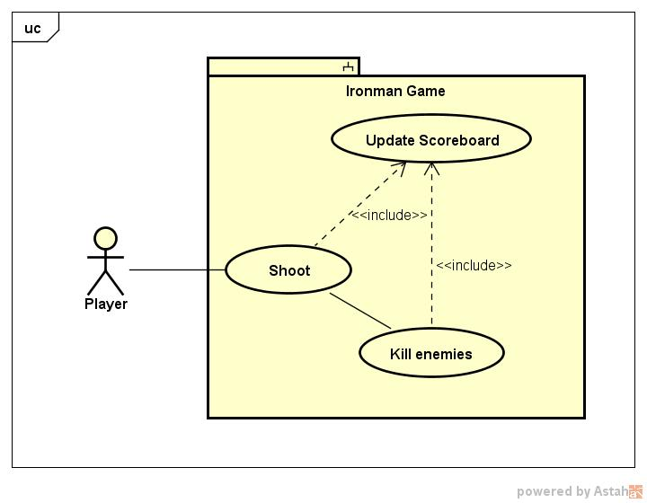

**Use Case Description**

|  |  |  |
| --- | --- | --- |
| **Use Case Name** | **Kill Enemies** | |
| Related Requirements | The player should be able to shoot to kill enemies. | |
| Goal In Context | The player shoots and kills all the enemies. | |
| Preconditions | The game has been started. There are enemies yet to be killed. | |
| Successful End Condition | The player shoots and kills at least one enemy. | |
| Failed End Condition | The player gets hit by the enemy. Number of lives gets reduced. Player gets killed. | |
| Primary Actors | 1. Ironman 2. Enemy objects 3. Shots | |
| Secondary Actors | Scoreboard | |
| Trigger | The player starts shooting | |
| Main Flow | **Step** | **Action** |
|  | 1  include::Update Scoreboard | The player starts shooting. |
|  | 2 | The shot hits the enemy object |
|  | 3  include::Update Scoreboard | The enemy object gets killed. |
| Extensions | **Step** | **Branching Action** |
|  | 1.1 | The scoreboard gets updated with the number of shots left |
|  | 3.1 | The scoreboard gets updated with the number of enemy objects remaining to be killed. |